Comp 3350: Computer Organization & Assembly Language

HW # 7: Theme: Conditionals, Booleans, Loops

- Draft a program that scans an array testing each index for a positive value. If a positive value is found the program should print “found” and the value. If no positive value is found the program should print “not found.”
Use:

.data
myArray1 SWORD -12,4,1,23,-21,45,12,-2
sentinel SWORD 0

Next, change the array so that all values are negative and show the run.

TITLE POSITIVE VALUE FINDER
Include Irvine32.inc

.data
myArray1 SWORD -12,-4,-23,-21,-45,-12,-2
messageS BYTE "found",0
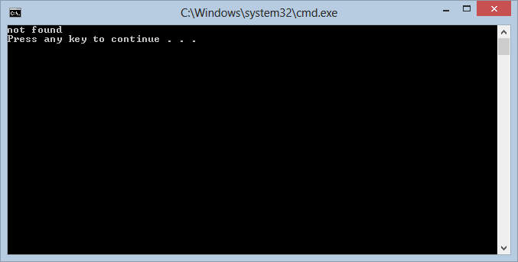
messageF BYTE "not found",0
.code
main PROC
mov ecx, LENGTHOF myArray1
mov ebx, 0
L1:
mov ax, [myArray1 + ebx]
TEST ax, 8000h
jz MSG1
add ebx, TYPE myArray1
LOOP L1
mov edx, OFFSET messageF
CALL WriteString
CALL Crlf
jmp exitP

MSG1:
mov edx, OFFSET messageS
CALL WriteString
CALL Crlf

exitP:
exit
main ENDP
END main

- In the following instruction sequence, show the changed value of AL where indicated, in hexadecimal. Answers without work shown, will not receive credit.

mov al, C2h
not al
FF
-C2
3D (one’s complement)

mov al, D3h
and al, 21h
11010011 | 01h
/\ 00100001 | 01h
00000001 | 01h

mov al, F3h
or al, 7Dh
11110011 | 0FFh
\/ 01111101 | 0FFh
11111111 | 0FFh

mov al, 2Dh
xor al, E5h
00101101 | C8h
Xor 11100101 | C8h
11001000 | C8h

3. Implement the following pseudo-code in assembly language (assume unsigned numbers). Declare Apple and Pear as byte sized variables.

- if ( (cx >= bx) OR (cx != val1) )
Apple = 10;
Else
Apple = 20;
TITLE 3a
Include Irvine32.inc

.data
apple BYTE ?
val1 WORD 30

.code
main PROC
mov bx, 20h
mov cx, 10h
cmp cx, bx
jae label1
cmp cx, val1
jne label1
mov apple, 10
jmp exitp
label1:
mov apple, 20
exitp:
exit
main ENDP
END main

- if ( (bx <= dx) OR (dx = val1) )
Pear = 0;
Else
Pear = 1;
TITLE 3b
Include Irvine32.inc

.data
pear BYTE ?
val1 WORD 10

.code
main PROC
mov bx, 05h
mov dx, 10h
cmp bx, dx
jbe label1
cmp dx, val1
je label1
mov pear, 0
jmp exitp
label1:
mov pear, 1
exitp:
exit
main ENDP
END main

